The Ultimate Switching Layout!

The title of this article could lead to misunderstanding. The layout I designed and built is an operational layout with lots of switching opportunities. I previously built an Inglenook style layout that I provided an article about in the May/June 2021 N-Rail Newsletter. The Inglenook is fun to operate on but I wanted something bigger for a home layout. I also built three Z scale layouts of which two are operational orientated. With that experience and having the opportunity to visit several other layouts I decided to jump off into the deep end of the pool.

I wanted to use a local railroad scene and a 1970’s time frame for the layout. I live in Mustang, OK and the Frisco was still operating through Mustang through the 70’s. The local rail line still has a one-mile-long siding in Mustang. After some research I determined that the route would be from mile marker 549, Wheatland, OK and run to mile marker 573, Amber, OK. This 24-mile segment would cover the towns of Wheatland, Mustang, Tuttle and Amber. With some creative imagination I would design eighteen industries, two interchanges, and three transfer yards. The original Frisco route had several sidings and small stations in its early history but currently only a couple of industries and sidings exist along this route. Today the Stillwater Central Railroad (SWLC) uses this trackage and sidings. The SWLC also services several industries on the way from Oklahoma City to Chickasha.

The beginning!
With my plan in mind, I began construction in mid-October 2021. I built six 24”X48” and one 24”X72” modules using half inch plywood and 1”X4” boards. I used 2”X2” wood for the legs. My goal was to complete the construction of the modules by Christmas. Since I am fully retired and was able to dedicated my time to the construction I completed the modules by November 10th, Marine Corps birthday. Hoorah!! By Thanksgiving I was able to start laying track to determine the feasibility of industries, sidings and yards I had in mind.
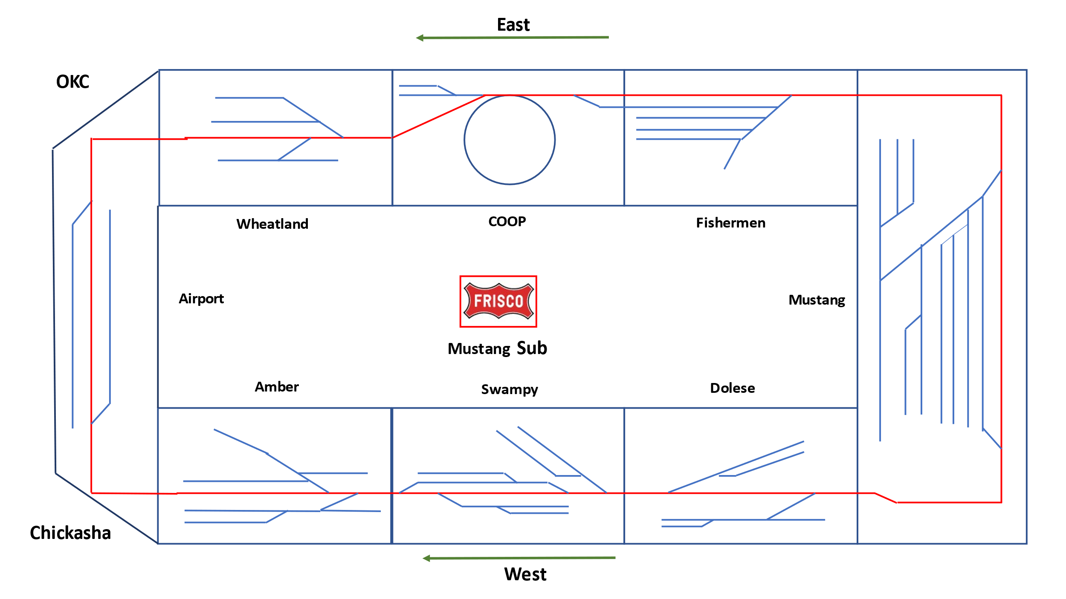
The Airport module was not added until I conducted a couple of operating sessions and found the operators had issues with moving freight cars at the Amber and Wheatland ends of the modules.

By Christmas the track was laid and I started to assemble the electrical equipment. I use Digitrax’ s Zephyr Express DCS52, Duplex Radio Transceiver UR93, Quad Power Manager PM42 and a home-made Raspberry Pie WiFi transmitter. I use two UT6Ds and one UT4D for throttle control. I can also use my phone utilizing WiThrottle. The layout is powered at four points so track power is very simple.
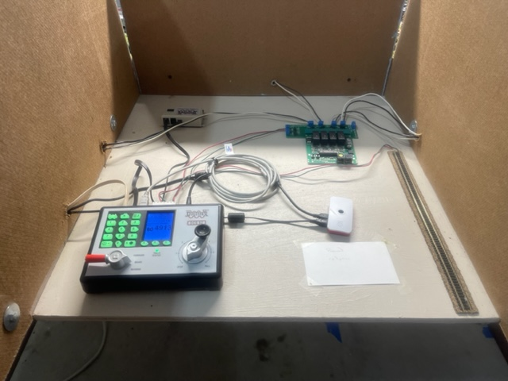

The electronic components are located on a 2’X2’ shelf located behind Mustang Yard and between the east and west bound modules. It is easily reached for repairs or replacement as necessary.

I held the first operating session in January 2022 to do a test of concept after I had designated industry locations. I found some short falls in siding lengths and the main transfer yards located at the Wheatland and Amber ends of the layout. I also realized the track grade over the South Canadian River bridge was way too steep. Modifications were made to these initial trouble areas and scenery started to be built on the layout. By May I held one more operating session and realized I really had to do something with the two end transfer yards. The obvious answer was to add an end module to close the loop. This solved my freight car movement problem at the transfer yards by adding eight additional spaces on each line. And it also provided a close loop for the entire layout so a train could now run all the way around the layout if desired. The construction of the Airport module was completed in about a week.

Since the completion of the construction, I have worked adding some items to make the layout more scenic and entertaining to look at. Here are some pictures of the layout so you can get a feel of the operations that occurs during a session.

We will start our tour at the Mustang Yard. This is where most activities start from during our sessions.
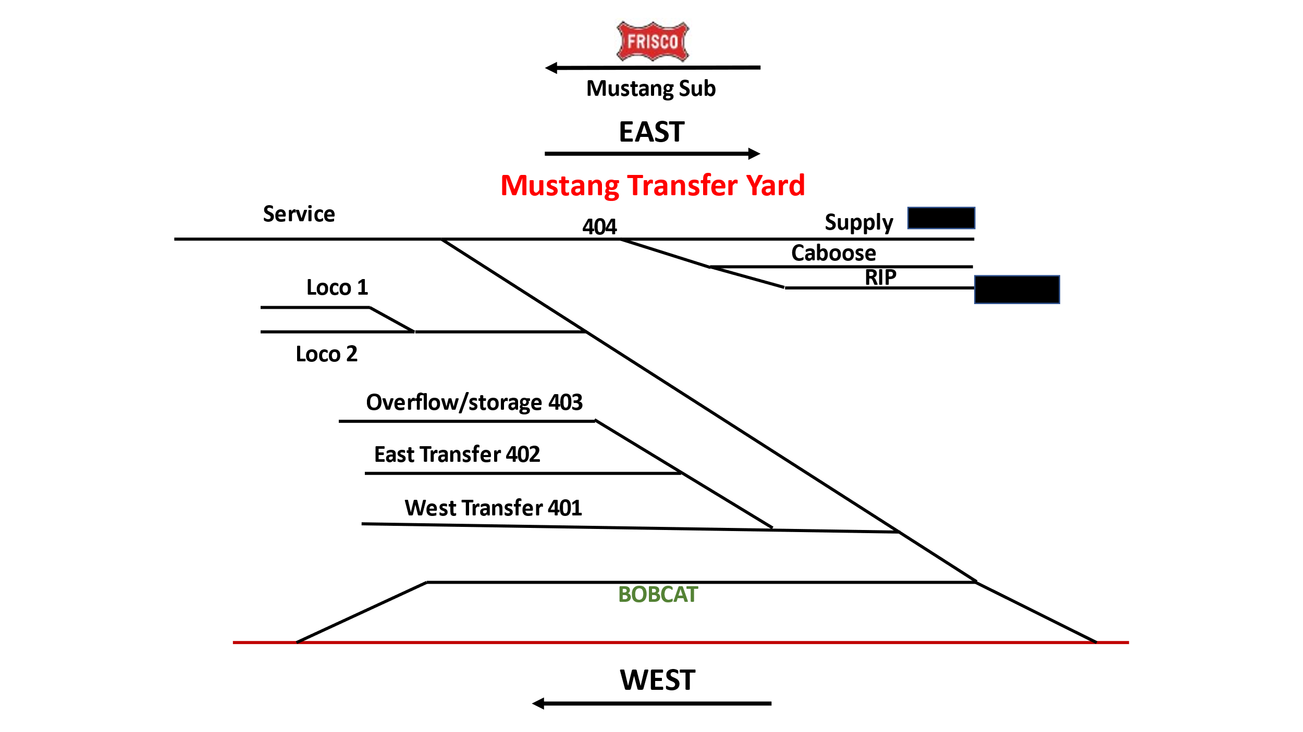
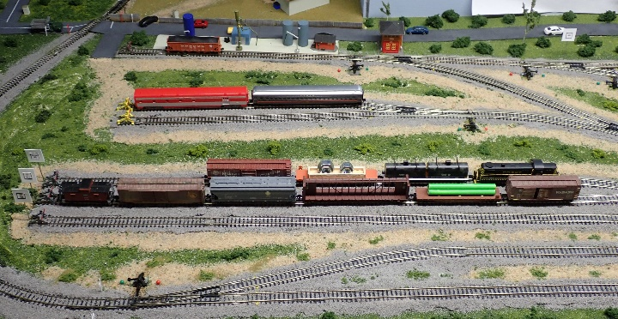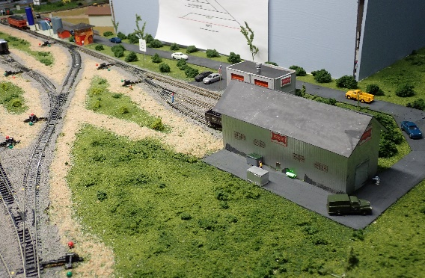
Mustang Yard Engine House and service area

A track diagram is located on each module sky board to help operators with orientation of industries and track. The east, west and overflow spurs are where most of the activities begin. The storage tracks and servicing areas are used by the yard master to move the two swicthers that are based at the yard.

Traveling east from the yard we cross the South Canadian river and arrive at Fishermen Yard and Cowboy siding. The two industries and two transfer/storage tracks provide the first opportunity to setout or pickup cars as necessary in accordance with the weight bills.
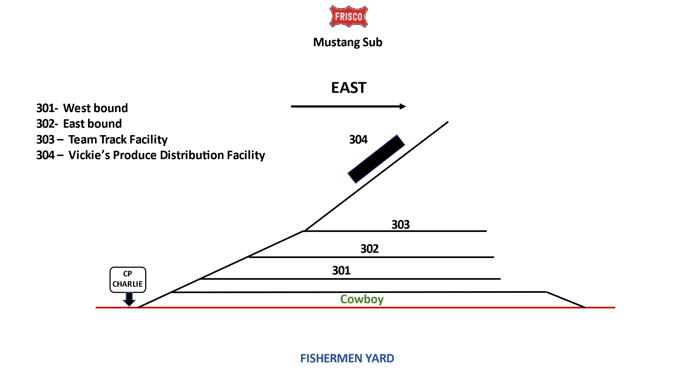
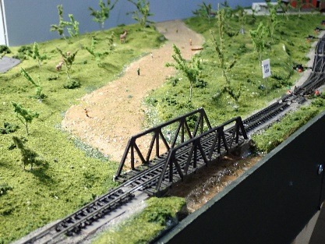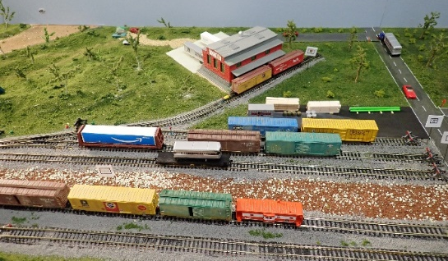
South Canadian River Fishermen Yard and Vickie’s Produce

The next module is COOP which has a grain elevator and the Missouri-Kansas-Texas (MKT) Interchange.
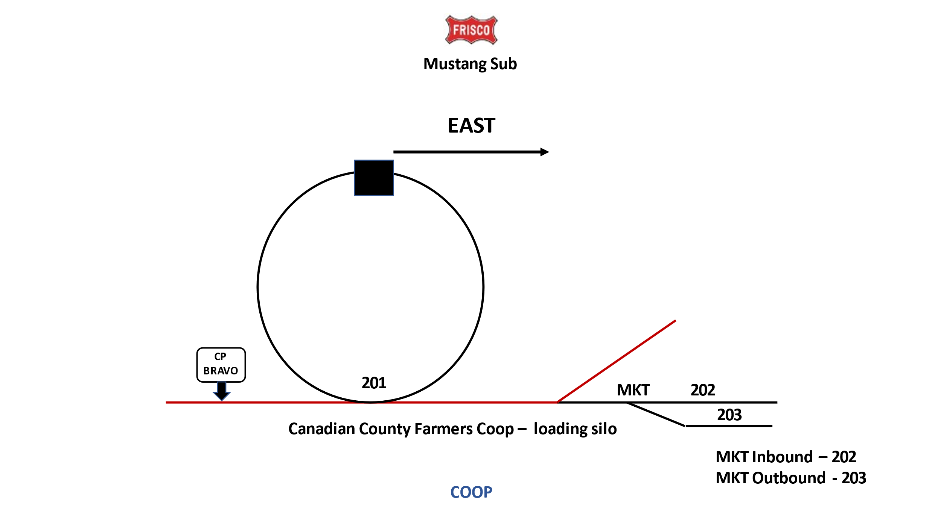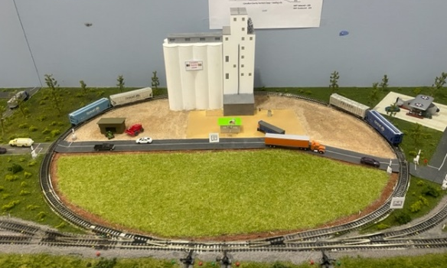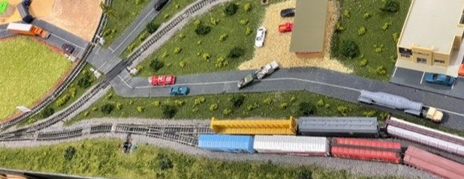
Canadian County Farmers COOP MKT Inbound/Outbound Spurs

This module provides for a lot of movement of freight cars moving from the COOP or the MKT interchange.

We come to the Wheatland module as we move east which has the most industries on this side of the layout.
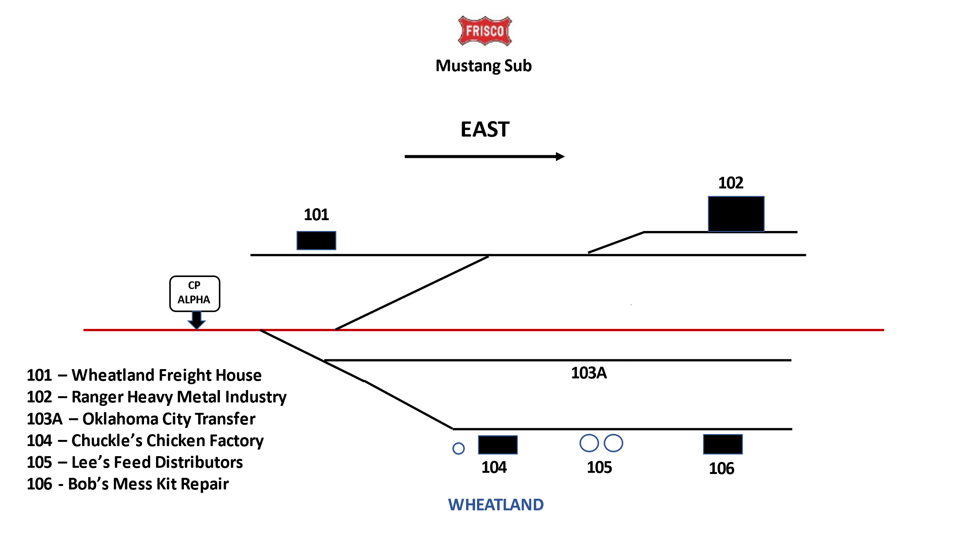
This is normally the busiest area during operating sessions on the east side. As I mentioned earlier when I first started operating on the layout freight cars would bunch up on the Wheatland staging spur. The same thing happened on the west bound side at the Chickasha staging spur. That is when the addition of the airport yard became a necessity.
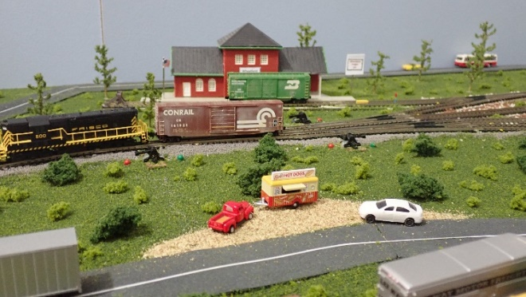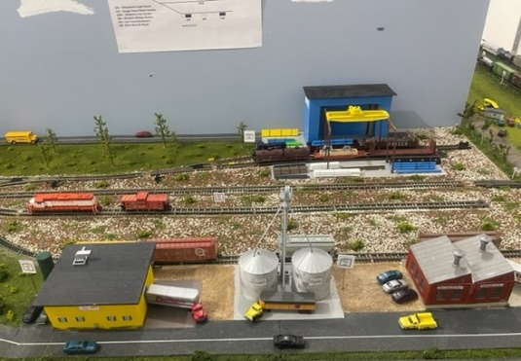
Wheatland Freight House Ranger Industries, Chuckles Chicken,
Bob’s Mess Kit Repair and Lee’s Feeds

The Airport module has really added more opportunities for operations.
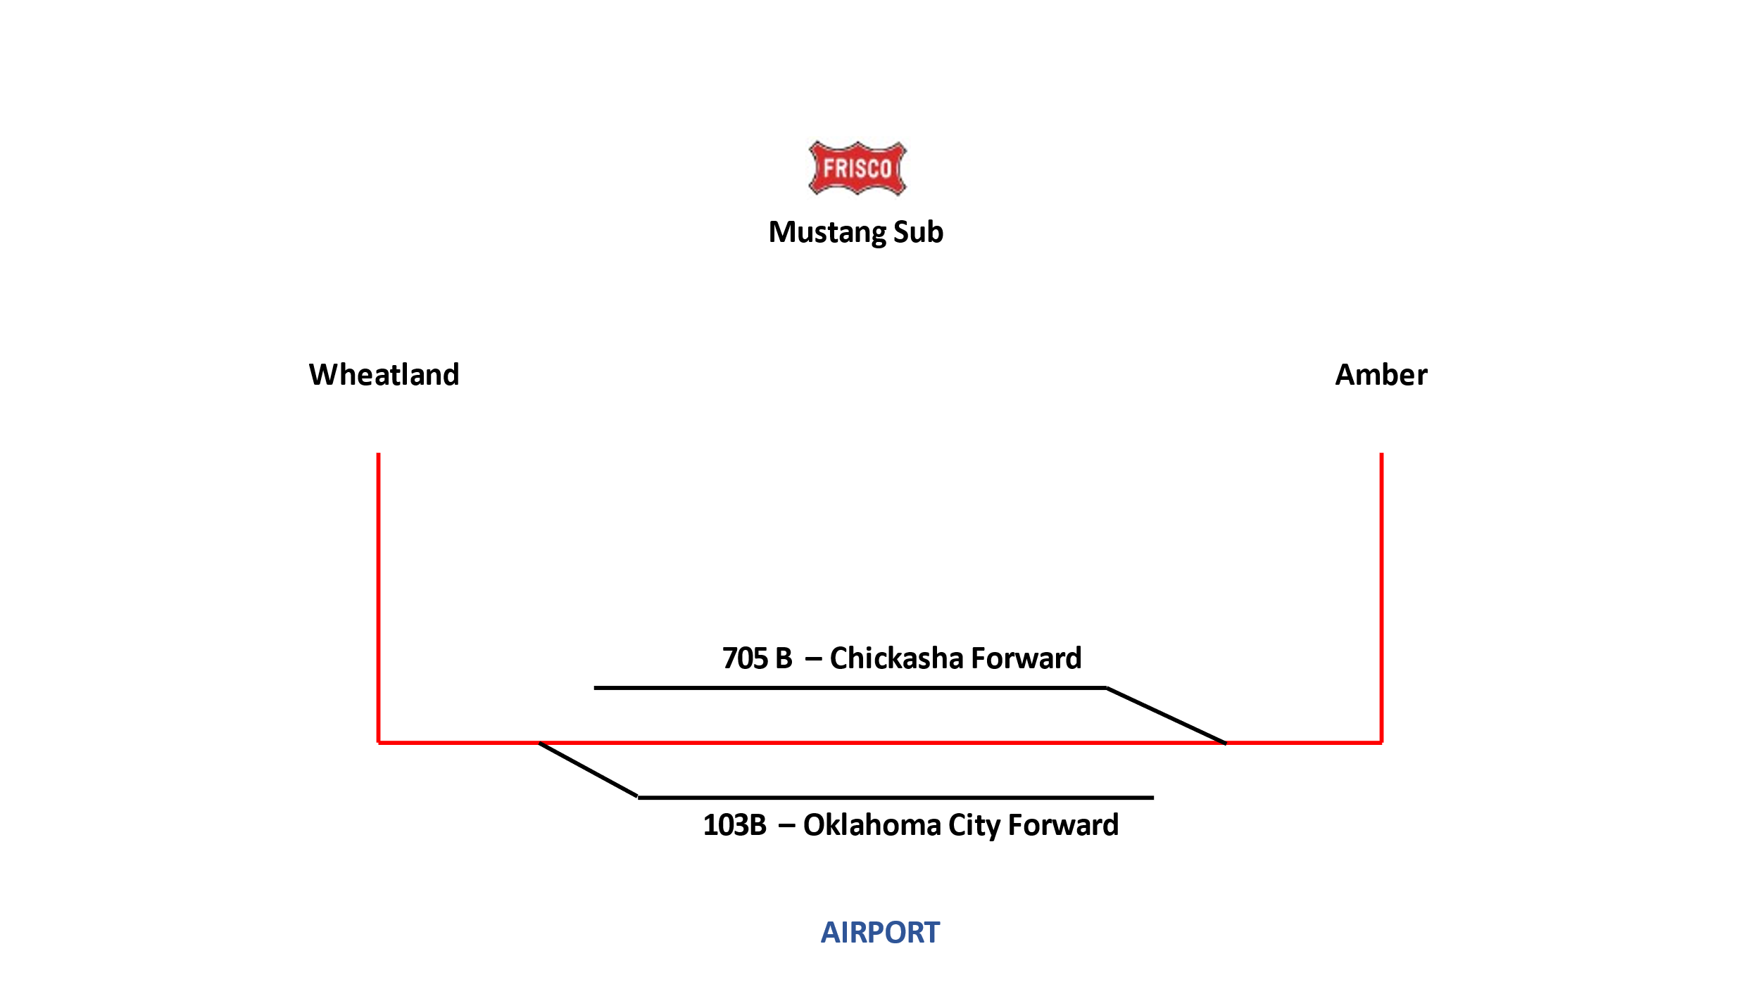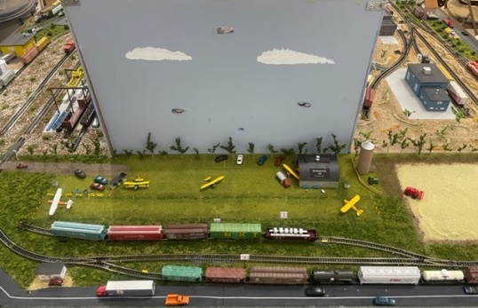

The two additional spurs help relieve the congestion problem.

We will now move to the west bound side coming out of Mustang yard. The first module is labeled Dolese. This module has three industries.
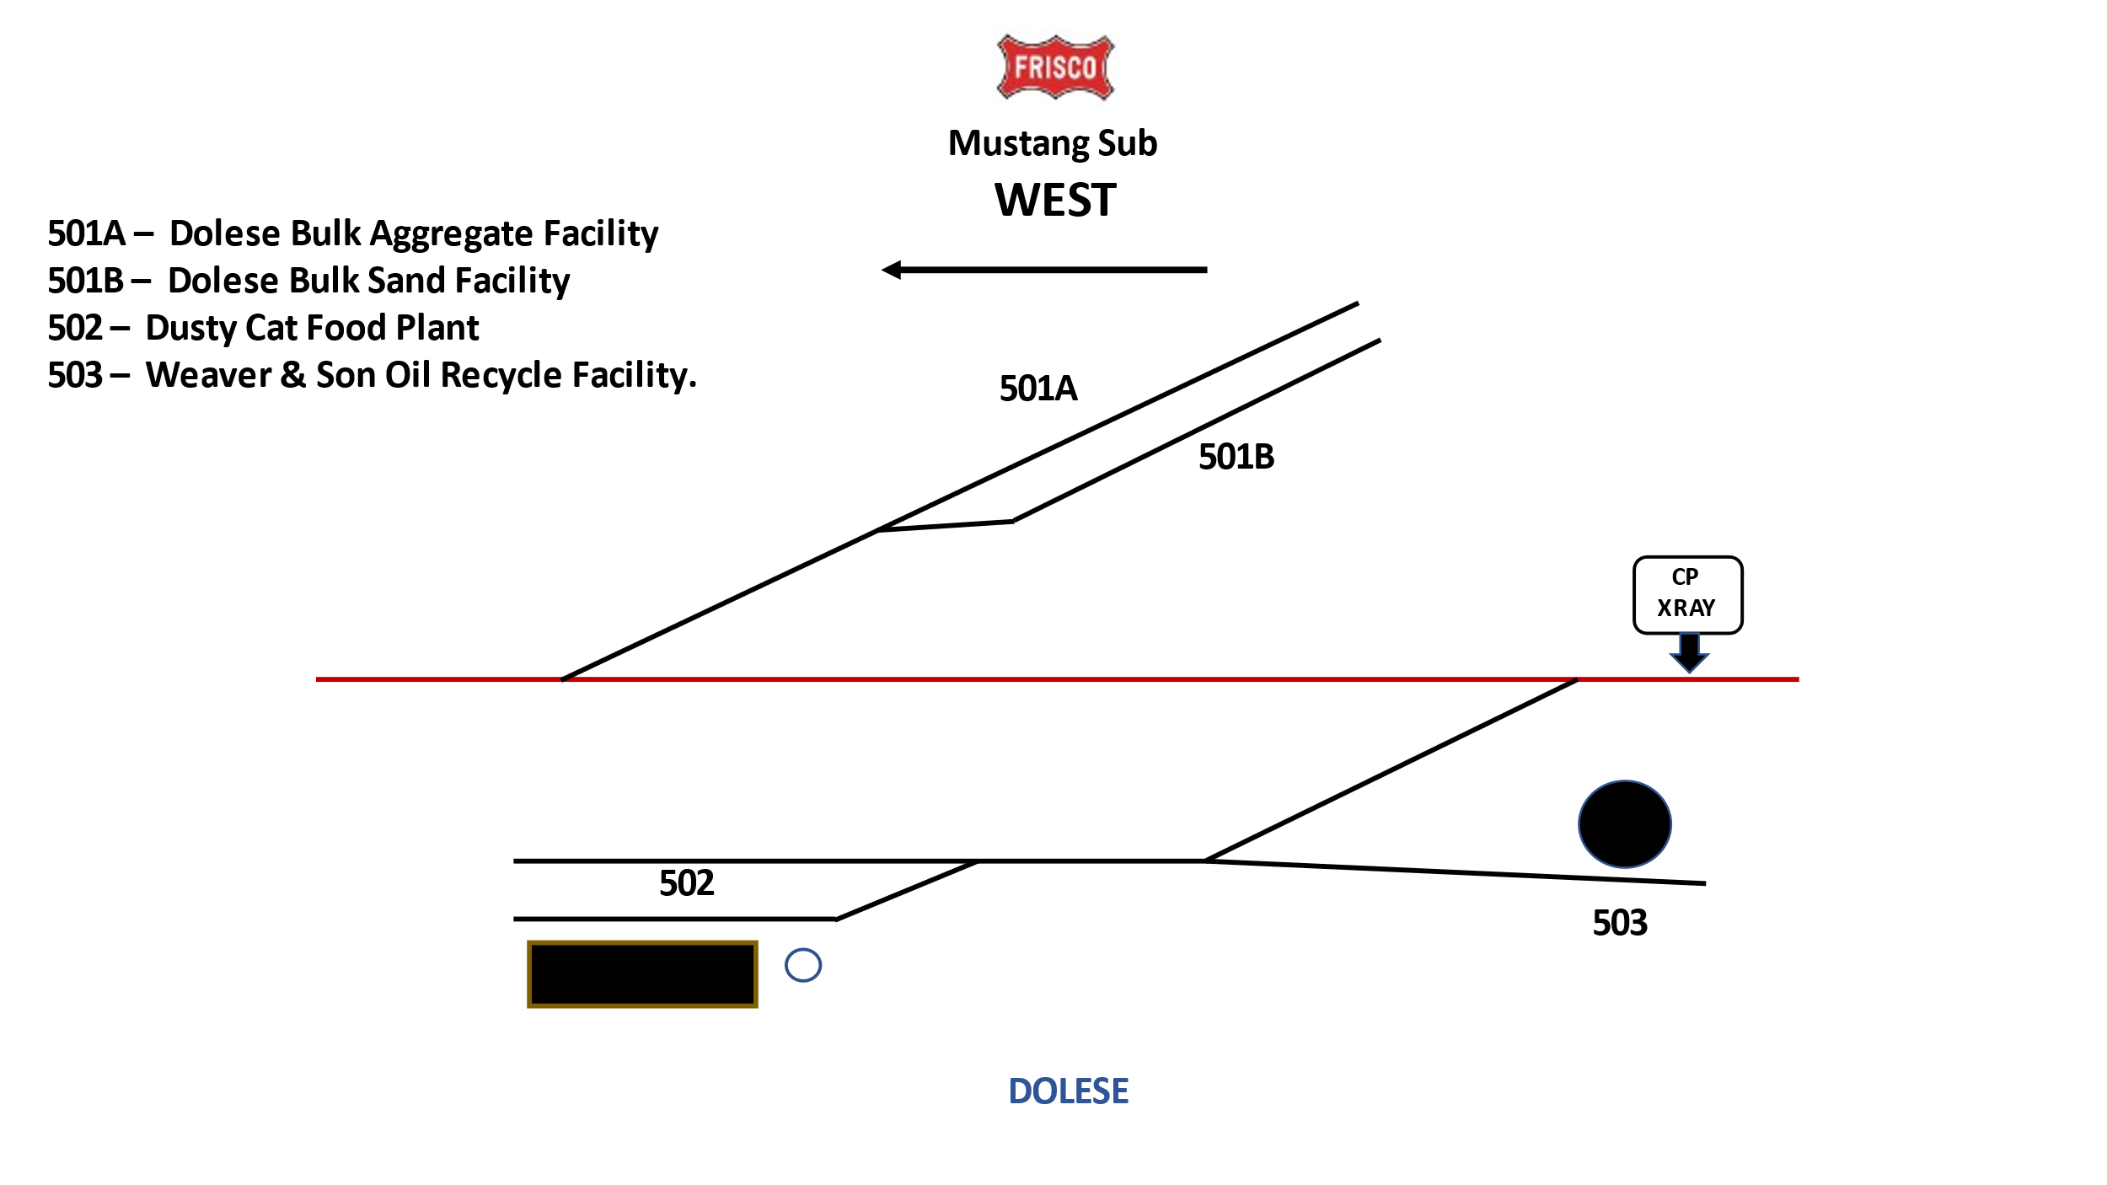

Dolese has two spurs. One for gravel and the other for fine sand.
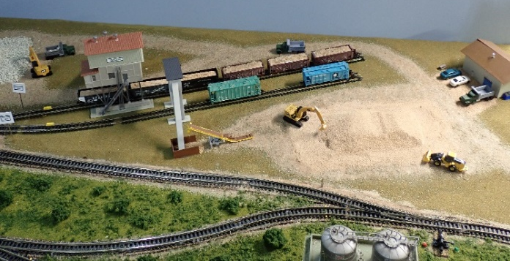

The first industry on the left is Weaver and Son Oil Recycling. Oil tank cars come in this facility to pick up recycled oil and deliver it to larger appropriate recycling facilities.

Dusty’s Cat Food Plant has two spots on the spur next to the plant for a box car and a tank car. The additional spur is for spotting either empty or full cars to be shipped.
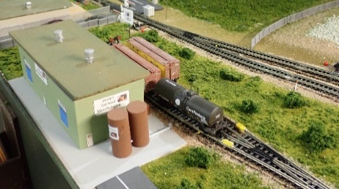

The next module is my favorite. It is labeled Camp Swampy. Lots of potential activity on this module.
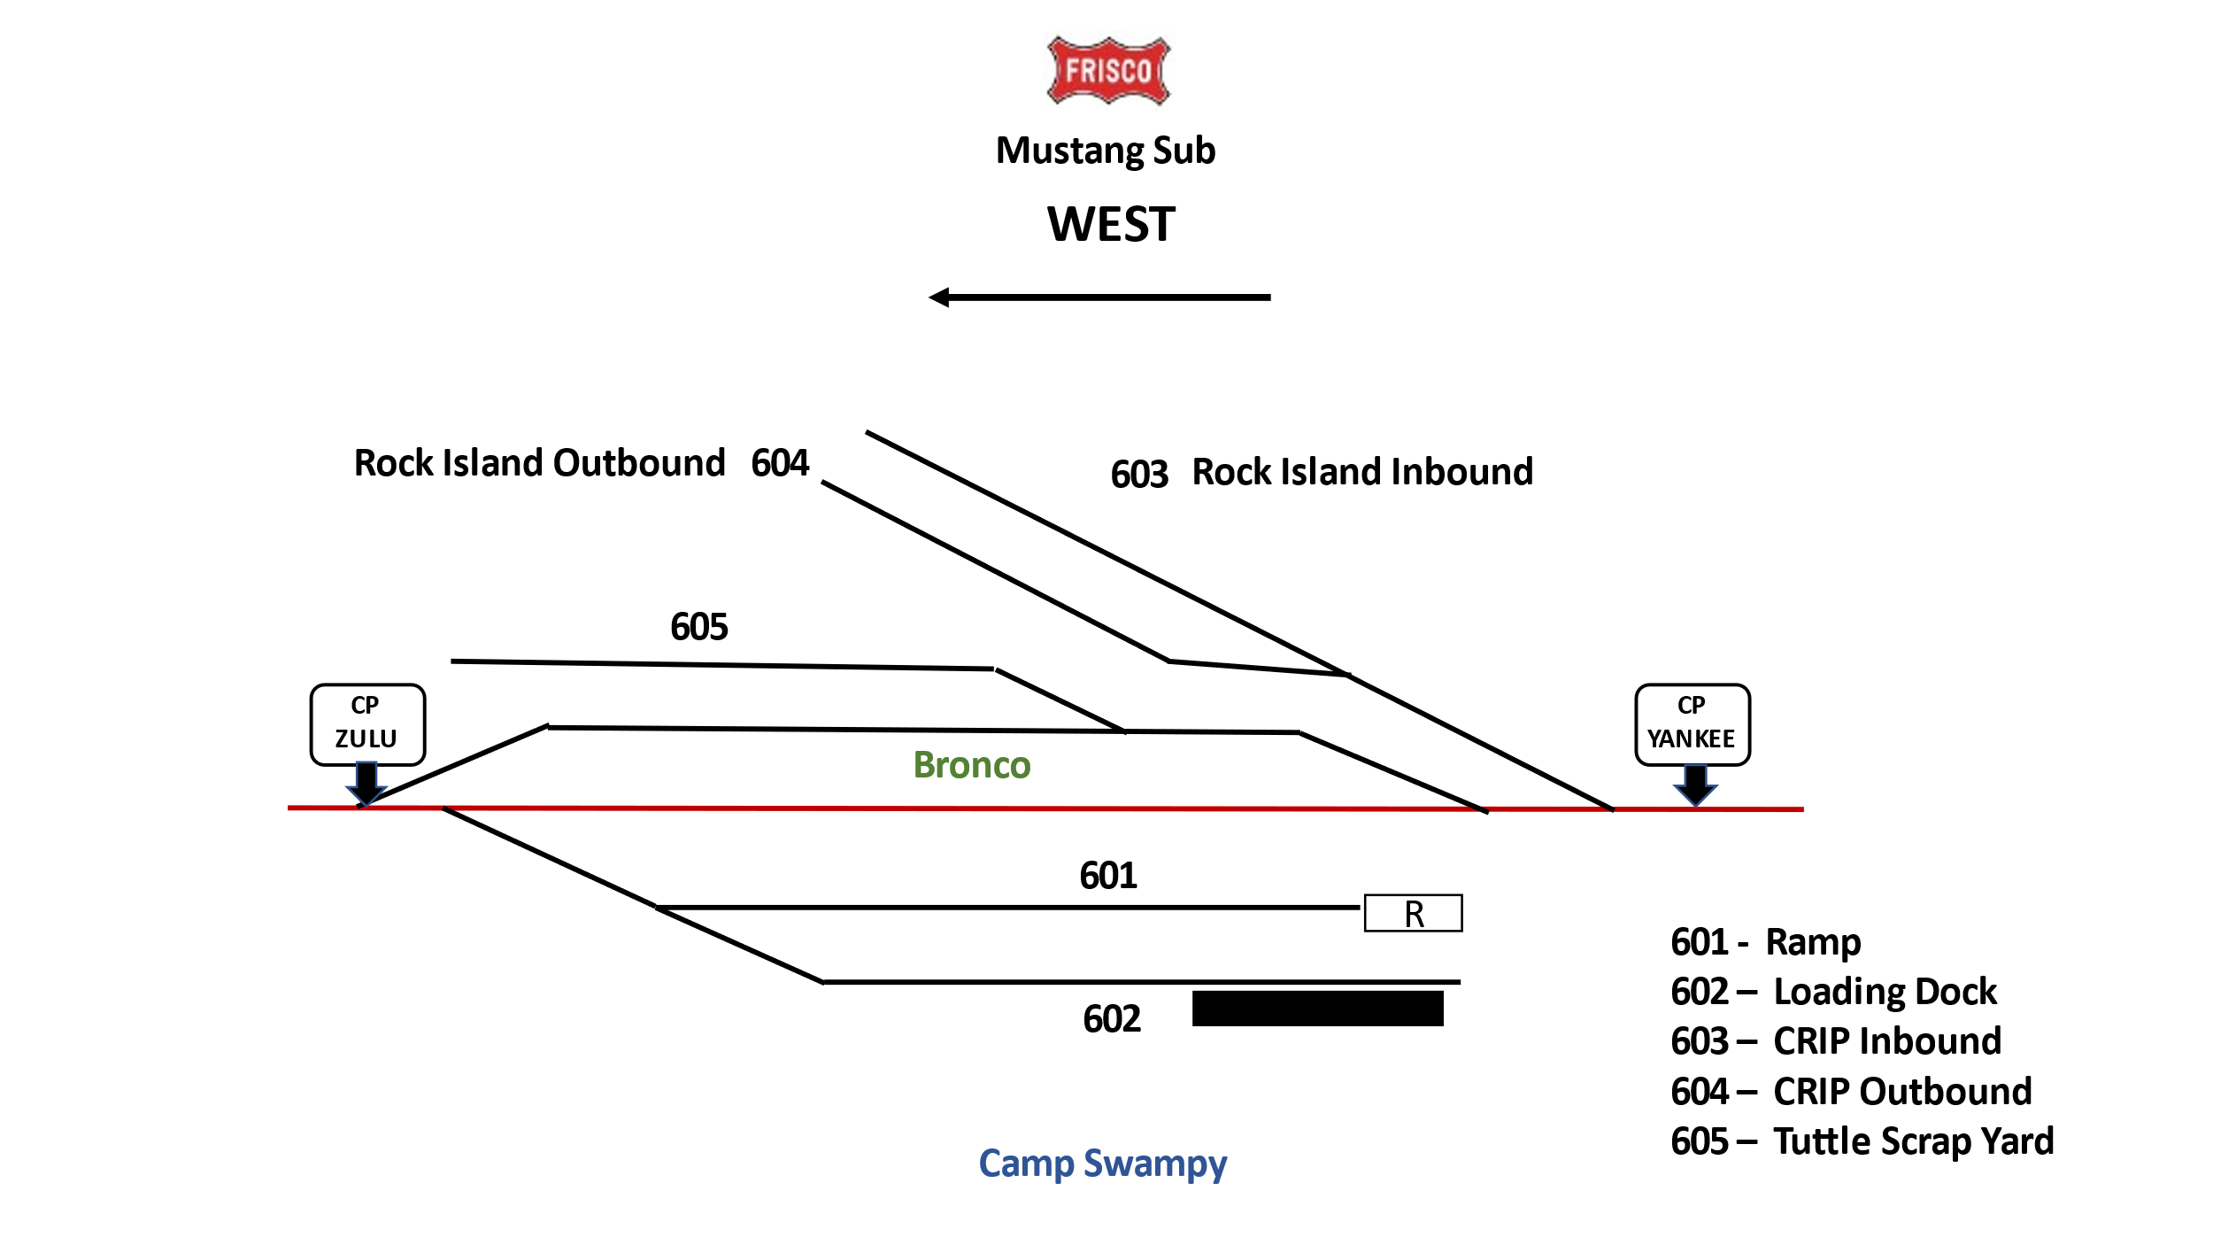
When I started laying track and designing the industries, I decided I wanted a military camp. I am a little prejudice since I am a retired Army Aviator and spent 31 years wearing a uniform. Camp Swamp reminds me of Camp Shelby in Mississippi. As I built the camp on the south side there was a big open area next to the Rock Island Interchange on the layout. One early morning a brain storm showed up and I thought why not a memorial to our military veterans. So, first I built Camp Swampy.

There are two spurs on Camp Swamp. One serves the ware house and the other the vehicle loading ramp.
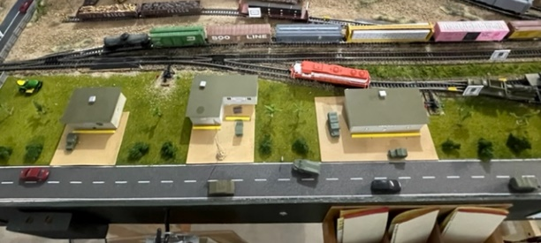

Across from Camp Swamp is Veterans Memorial Hill. The hill is a salute to all those who gave all and to those of us fortunate enough to come home and live out our lives with family and friends. There is a chapel, museum and a UH1H parked on the helicopter pad.
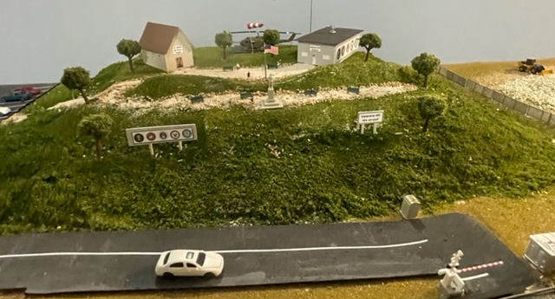

The Rock Island Interchange has outbound and inbound spurs. This interchange in real life is actually in Chickasha so a little compression is being used.

The Bronco siding is in front of the Tuttle Scarp Yard. The entry into Tuttle Scrap spur makes for challenging spotting especially if there is a train located on the siding.
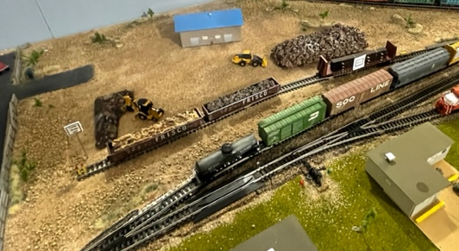

From here we move to the Amber module. This module has five industry areas and a staging spur. Like the Wheatland module on the east side this module provides for the most activity on the west side. There are three spurs on each side of the main.
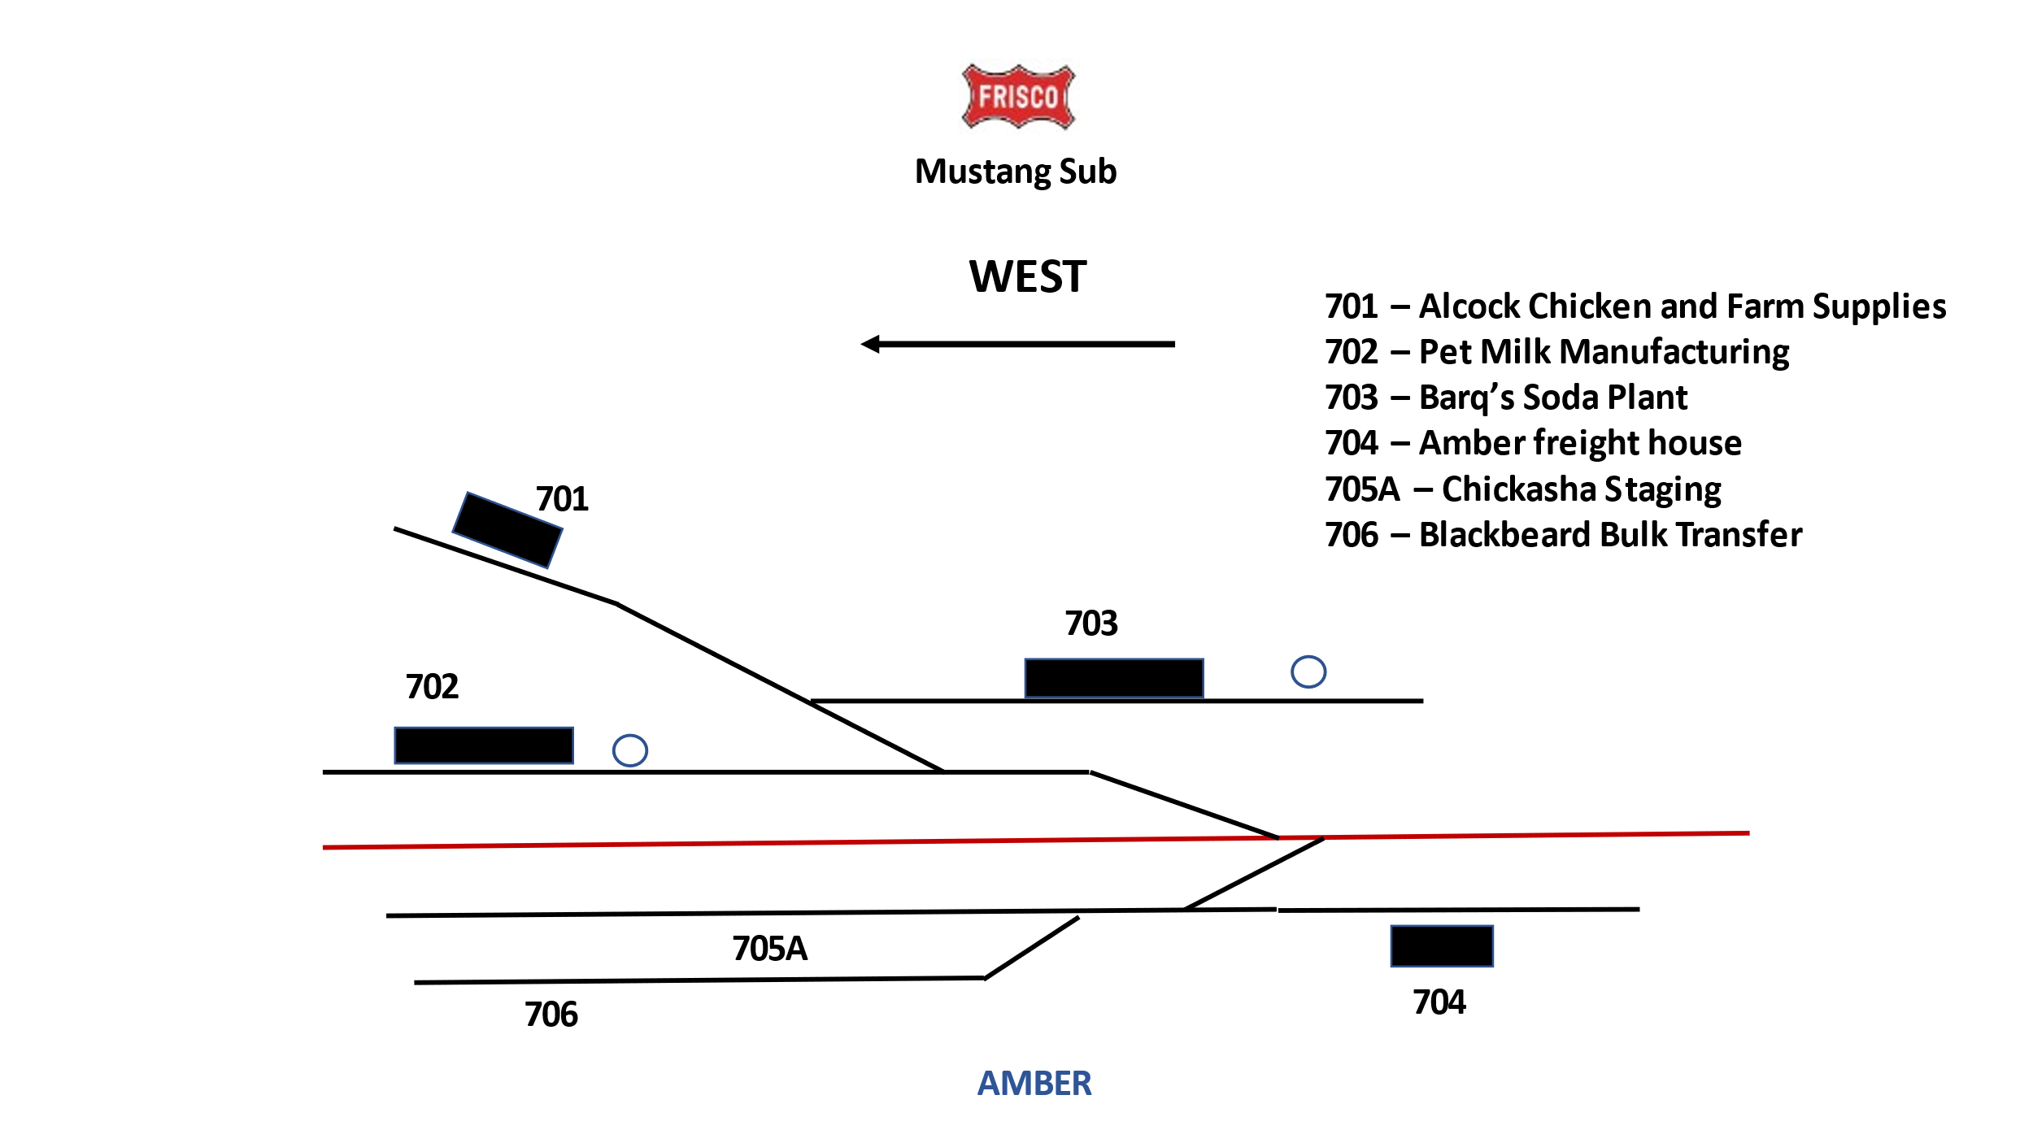
The first industry on the north side is Barq’s Soda Plant. I like Root Beer and Cream soda so it made sense to me. Room for two box and one tank car with corn syrup on this spur.

The next facility is PET condense milk plant. This plant actually existed in Chickasha. A retire Frisco/BNSF engineer showed me a picture when he was a conductor back in the early 70s of a train pulling a newly loaded box car from PET which was positioned right behind the Frisco GP38 and in front of a long line of tank cars.

The industry right behind PET is Alcock’s Chicken, Goat and Lubber company. A very diverse company specializing in domestic animals and farm lumber and hardware. This spur provides for challenges placing cars into Barq’s and requires so creative thinking.

The first industry on the south side is Amber freight house. This spur has room for two cars.

The next industry west is the Blackburn Bulk Transfer facility. Up to three freight cars can be placed here for product transfer. Behind this spur is the Chickasha staging spur. Cars are moved back and forth from this spur to the Chickasha Transfer on the airport module.

Operations
I try to run operating sessions once a month to allow members of our OK N-Rail Club to have an opportunity to operate on the layout. My concept is to have one or two operators (engineer/conductor teams) operate from either the Mustang Yard (center stage) or start from the Wheatland or Amber area to move trains. Trains starting from the Mustang Yard are assembled by the Mustang Yard Master and are taken either east or west and distributed according the freight car weigh-bills. The consist normally has six or seven freight cars, one locomotive and a caboose. The caboose is supposed to be used as a push lead anytime the train is moving any distance down the main and the locomotive is not in front.

Most sessions have lasted about two hours with each operator moving two to three trains. I spend most of my time during an operating session either helping with issues that might come up or acting as yard master. The yard master actually takes a train that comes in from the east or west and blocks it to facilitate spotting when the engineer moves the train from Mustang yard. This speeds the operations up a little for the engineer when they arrive at the location where they decide to break the train down for setting out cars.

I work or operate the layout just about everyday just to stay ahead for the next session. Playing mental gymnastics trying to make sure the trains are set up so all 118 freight cars are not on one side of the layout at once. I also enjoy continuing to add scenery to improve the quality of the visual effects of the layout. I have made several operations videos of the layout and share them on our clubs Facebook page, OK N-Rail.

If anyone has any questions and suggestions, please feel free to contact me. I am listed on the member’s page.

Martin Weaver

